William G. Lowrie Department of Chemical and Biomolecular Engineering

9th Annual Graduate Research Symposium 2020

Sponsored by The Dow Chemical Co.

Keynote Speaker
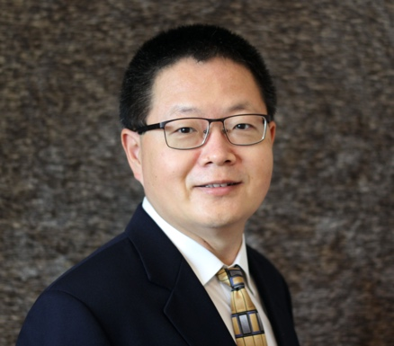 | Dr. Jian Zou graduated from Department of Chemical and Biomolecular Engineering at The Ohio State University in 2007. His doctoral dissertation research at Ohio State under the guidance of Dr. Winston Ho focused on membrane separation and gas separation.  After graduating, he joined Momentive Performance Materials located in West Virginia. He successfully led more than 85 scale-ups of more than 12 new products and production processes from lab scale to industrial scale.  In 2015, he joined Baker Hughes and moved to Houston. He is responsible for new production introduction and process development at the Oilfield and Industrial Chemicals division of Baker Hughes.
Dr. Jian Zou
Sr. Manufacturing Engineering Staff Manager
Baker Hughes Company
Dr. Zou is currently leading a team to develop a new polymerization process for ultra-high molecular weight polymers, used for drag reducing agents.
He received MS in Materials Science and BS in Polymer Engineering from Beijing University of Chemical Technology, China. While working at Momentive, he obtained an MBA degree at Ohio University.
Dr. Zou has filed six U.S. patent applications and three China patents issued. He co-authored two book chapters and ten journal articles.

